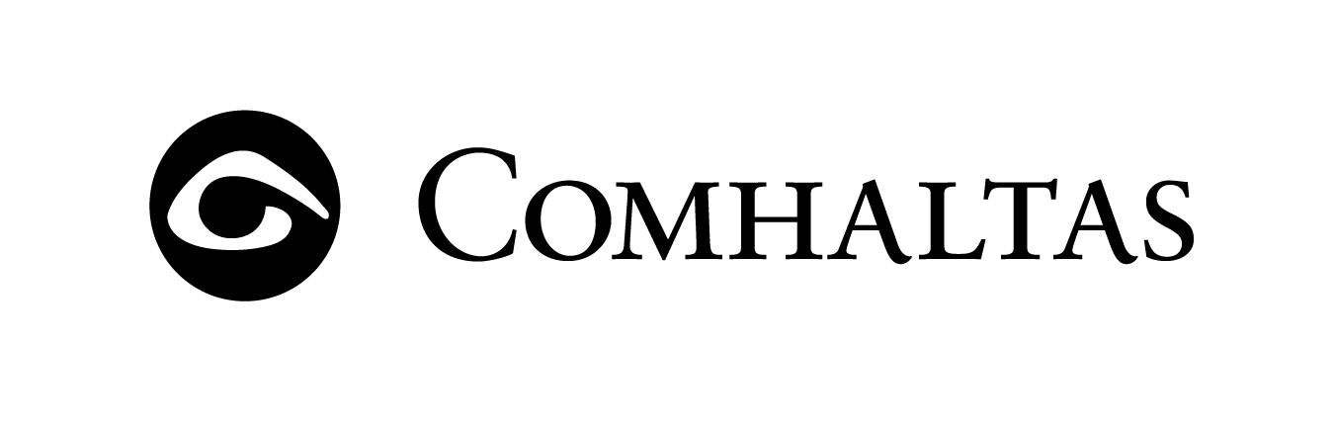
Fleadh Cheoil Chontae Aontroma
Port Chluain Eoghain
25 – 26 Aibreán 2020

IMPORTANT Solo Competitions will be held Saturday 25th April with Grupaí Cheoil,
Ceili Bands and Dancing Competitions held on Sunday 26th April.
Competitions will be held in St Mary’s PS and Wild Duck Inn

All Saturday competition venues will commence at 10:00 am, and continue during the afternoon. Sunday venues will commence at 12 noon

Under 10 Under 12 12 - 15 15 - 18 Over 18
(Tin Whistle Solo)
The date for determining age is 1st January 2020

Foirm Iontrála: Fleadh Aontroma 2020 (Entry Form: Antrim Fleadh 2020)
Portglenone 25–26 April 2020
Ainm(Name) _________________________________________________ D.O.B. (if U18) ______________________
Seoladh(Address)_________________________________________________________________________________
Craobh (Branch) ________________________________ Guthán (Phone) ________________________________
Comórtas (Competition) ___________________________________ Aois Ghrúpa (Age Group)_______________
(identify if Solo or Slow Air – if applic)
*** Only one competition per entry form ***
Rogha Ghléas‐Miscellaneous: (Please name your instrument) ______________________________________
- Tionlacan‐Accompaniment: (Please name your instrument) ________________________________________
*Duet and Trio: (Please provide D.O.B. (if U18) and the combination of instrument and competitor)
___________________________________________________________________________________________ ___________________________________________________________________________________________
___________________________________________________________________________________________
Competitors who have paid a Membership Fee to their CCE Branch,
will not be charged a competition entry fee.
Entry fees for non-members: junior will be £7.00 and senior £15.00 per competition
Please return entry form(s) to your Branch Secretary or
E-mail: magnew610@gmail.com (PDF or Word format)
or by post to Martin Agnew, 8 Culnafay Rd, Toomebridge Co Antrim, BT41 3QG
(Contact Tel No 028 2587 1695)

 Closing Date Saturday 14th March 2020

